**Training Requirements for all Head Coaches and Assistant Coaches**

These are the training requirements of all Head Coaches and Assistant Coaches in AYSO.

* **Sudden Cardiac Arrest**
* **AYSO Safe Haven**
* **SafeSport**
* **Concussion Awareness**
* **Coach License - Age Specific Online Coach Training**

**You will find your status for each of these in your online account by selecting the “Volunteer” tab:**

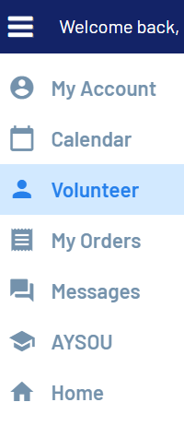

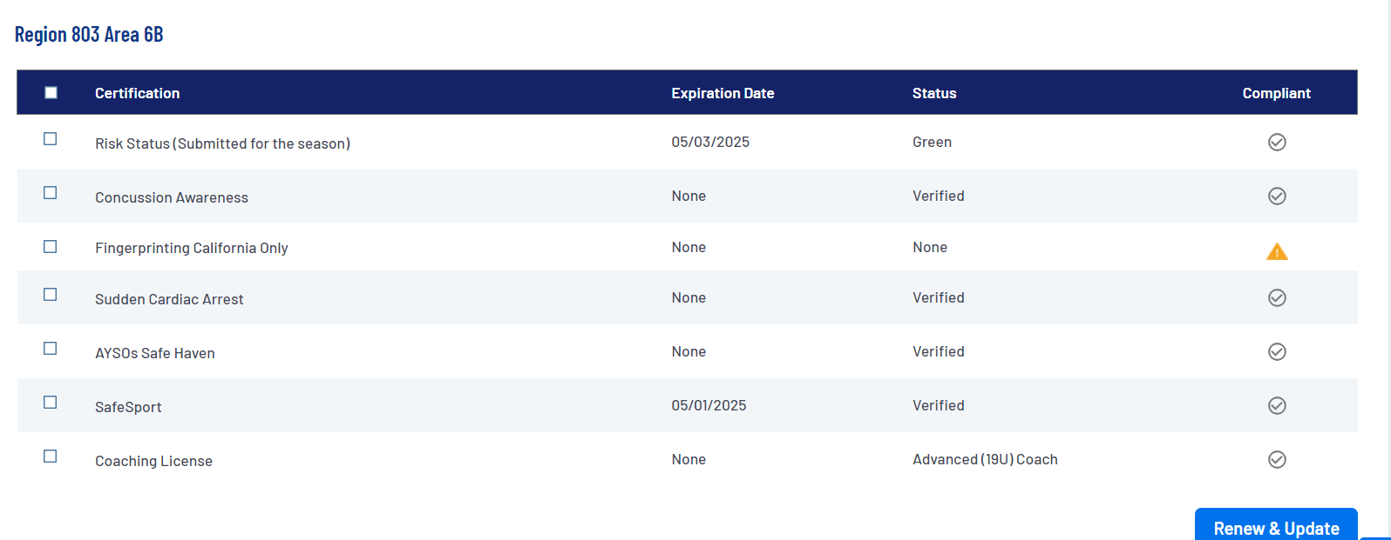

**Online Training Courses at AYSOU**

Once you complete the volunteer process as a coach, you will have access to the AYSOU training site. AYSO has moved to a single sign-on process. Here are instructions to access your AYSOU training site:

<https://aysovolunteers.org/how-to-access-aysou/>

Go into the Training Library and select your course:

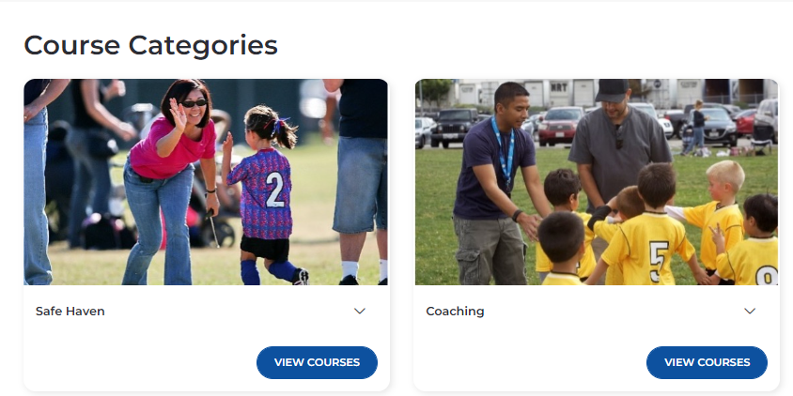

National has partnered with "The Coaching Manual" and has been recommending coaches sign-up for free access to this. The website is <https://ayso.thecoachingmanual.com/ayso-home>

**Coach Manuals at AYSOU**

When you complete the training, at the end of the online web module, you will be able to download your coach manual in .pdf format. **This will serve as your Coach Manual. These are available in the Document Library** of your AYSOU site.

**----------------------------------------------------------------------------------------------------------------------**

**New Coach Orientation August 19 at Indoor Sports Center 630-730**

**For all new head coaches and assistant coaches, there will be required New Coach Orientation training:**

Required for ALL new Coaches and Assistant Coaches

Date – Monday, August 19

Time – 6:30 pm -7:30 pm

Place – Indoor Sports Center

3456 Craig Rd.

Eau Claire, WI 54701

**New Coaches and Assistant Coaches are required to come!**

Wear tennis shoes or running shoes – do not wear sandals or dress shoes!

**----------------------------------------------------------------------------------------------------------------------**

**Coach Training by P2 on Sunday September 8**

**“What should I do?” at practice is a common concern of coaches. We have hired P2 Soccer Training instructors to facilitate age specific training for coaches on practice sessions.**

**Location:**

Gymnasium at Robbins Elementary School, 3832 E Hamilton Ave, Eau Claire

**September 8 Schedule:**

Noon – 1:00 pm   U6 Coaches

1:00 pm – 2:00 pm U7/U8 Coaches

2:00 pm – 3:15 pm U9/U10 Coaches

3:15 pm – 4:30 pm U11/U12 Coaches

4:30 pm – 5:30 pm U14/U19 Coaches

**---------------------------------------------------------------------------------------------------------**

**All Coach Meeting August 22 630-730 at Bethesda**

**Bethesda Lutheran**

**123 W. Hamilton Ave. Eau Claire**

**Will have equipment pick up**

**Cover any questions**